**Create the IBM Watson IOT platform and a device**

|  |  |
| --- | --- |
| **TEAM ID** | PNT2022TMID29999 |
| **PROJECT NAME** | Gas leakage monitoring and alerting system |

Step 1:

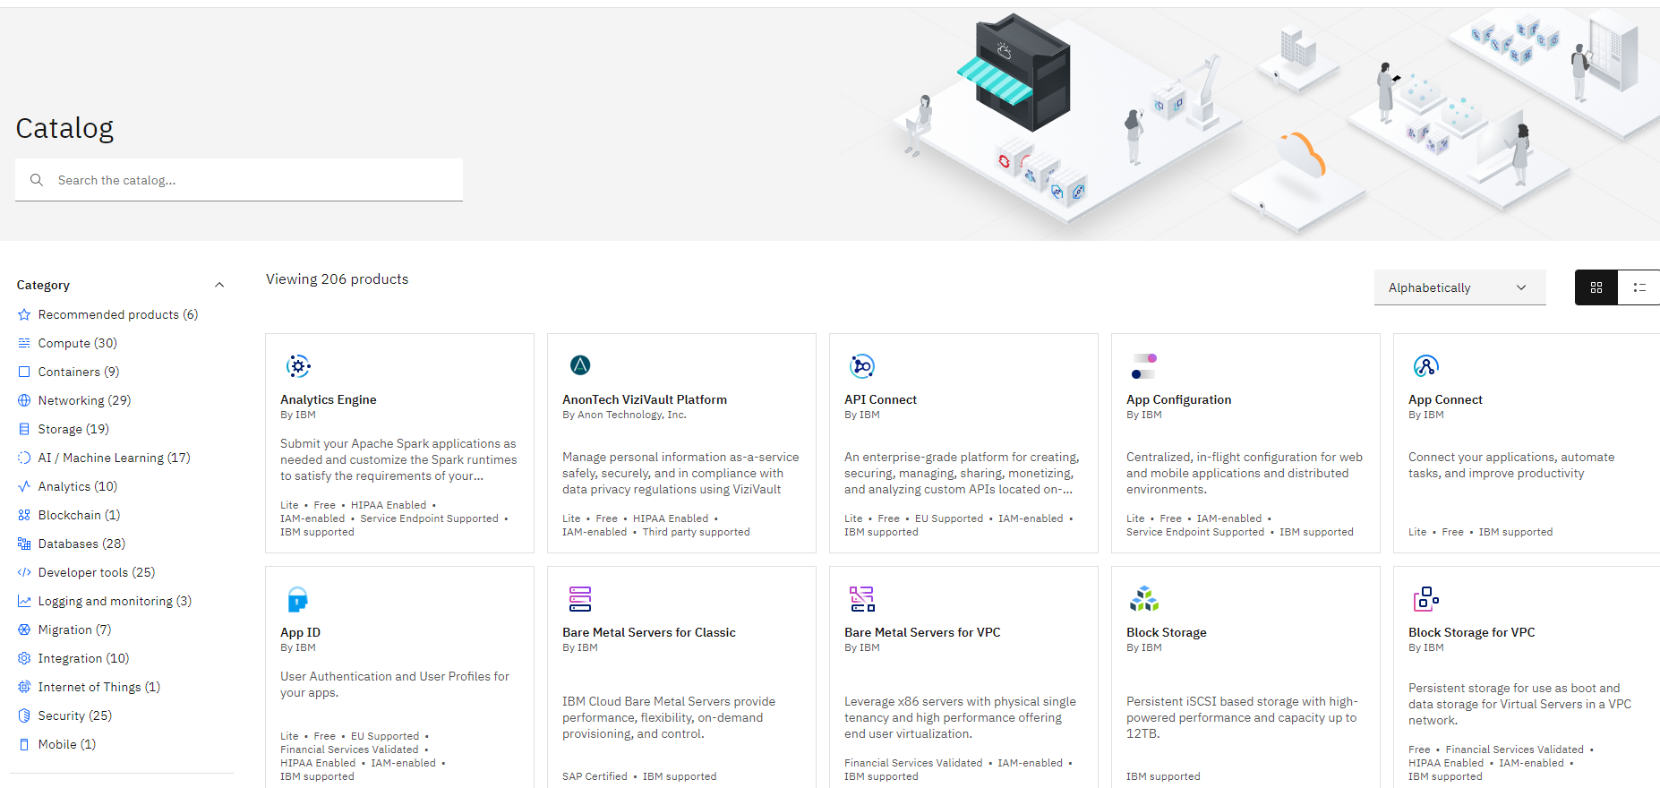

Step 2:

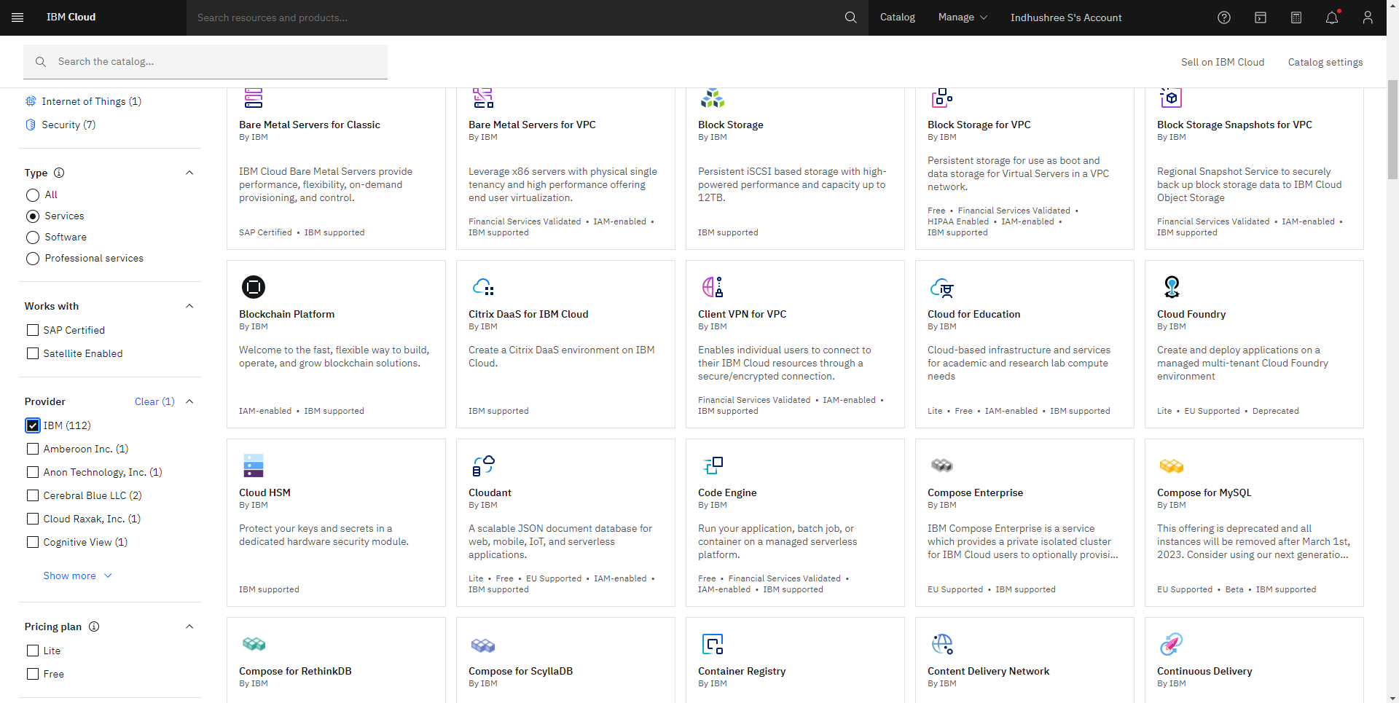

Step 3:

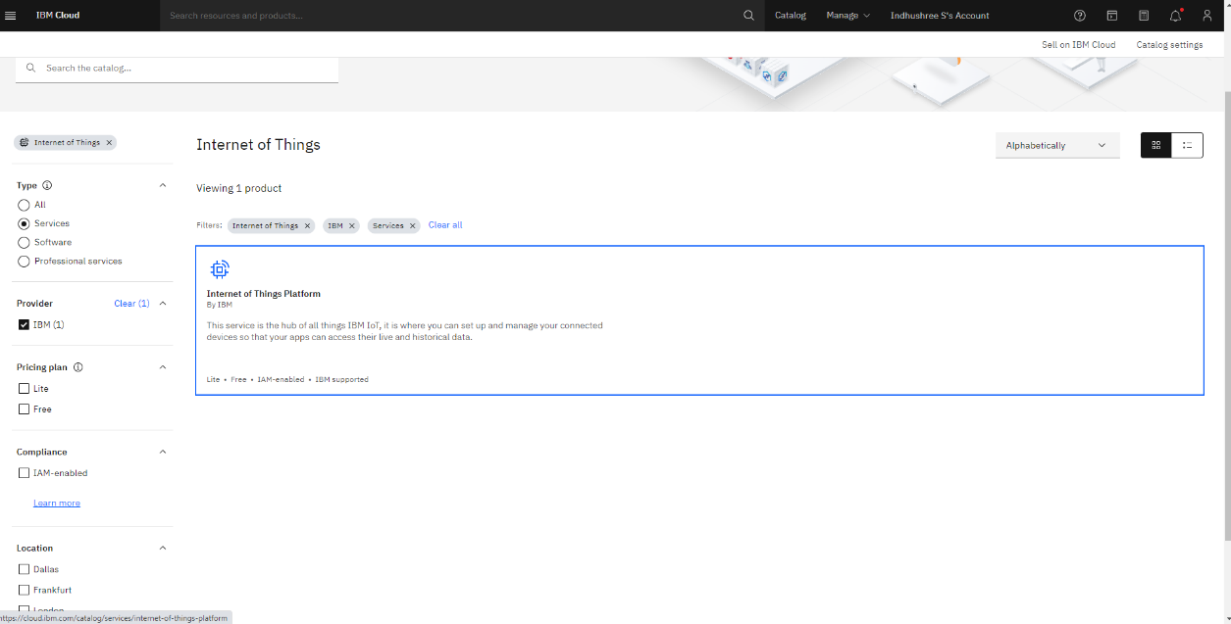

Step 4:

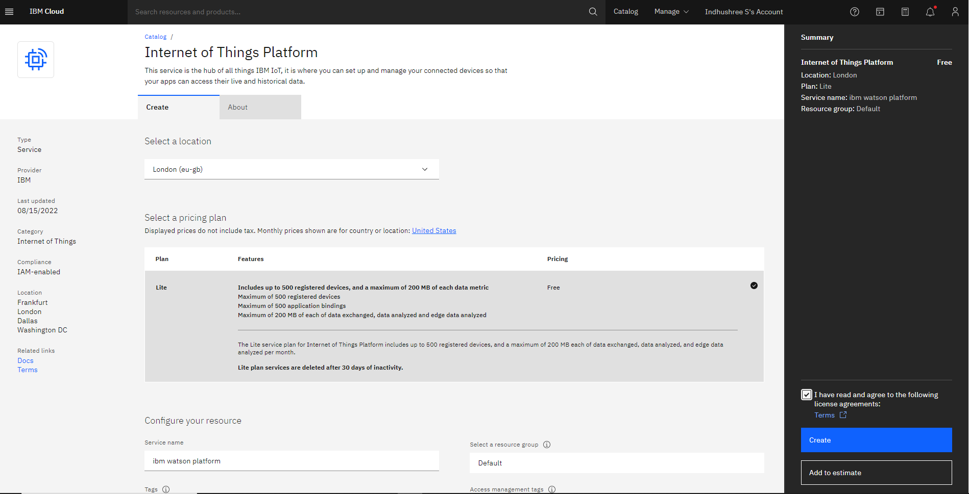

Step 5:

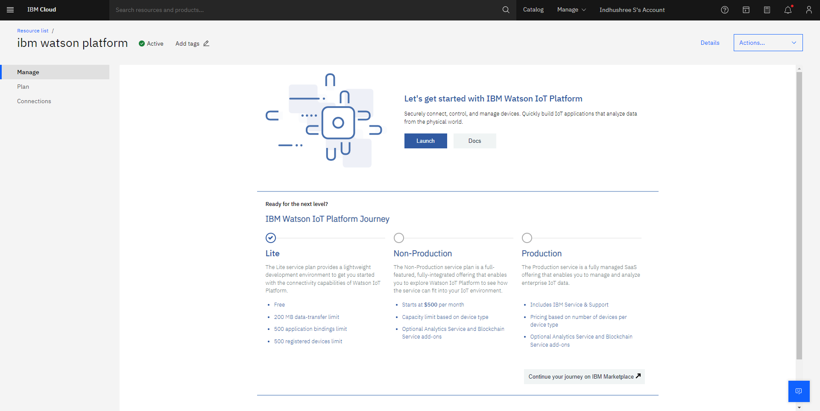

Step 6:

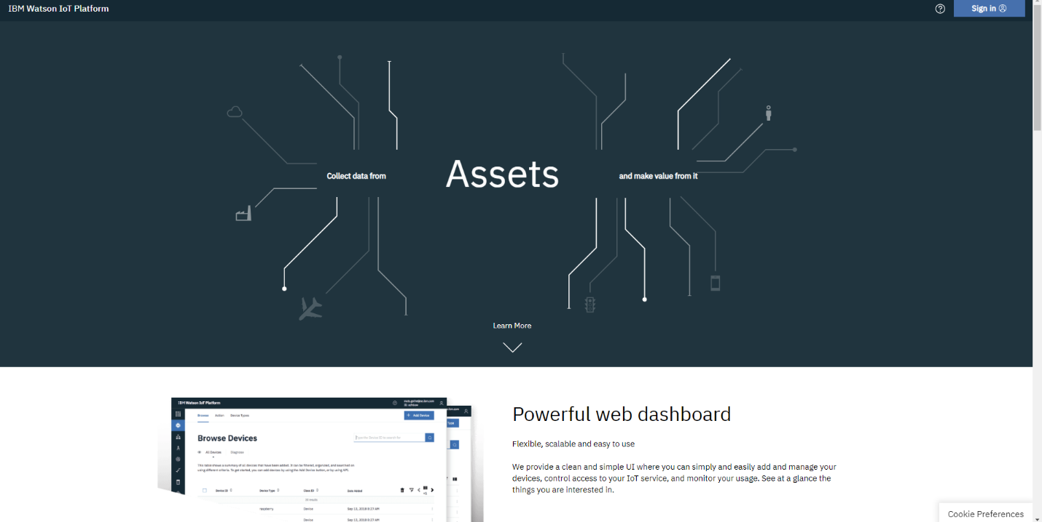

Step 7:

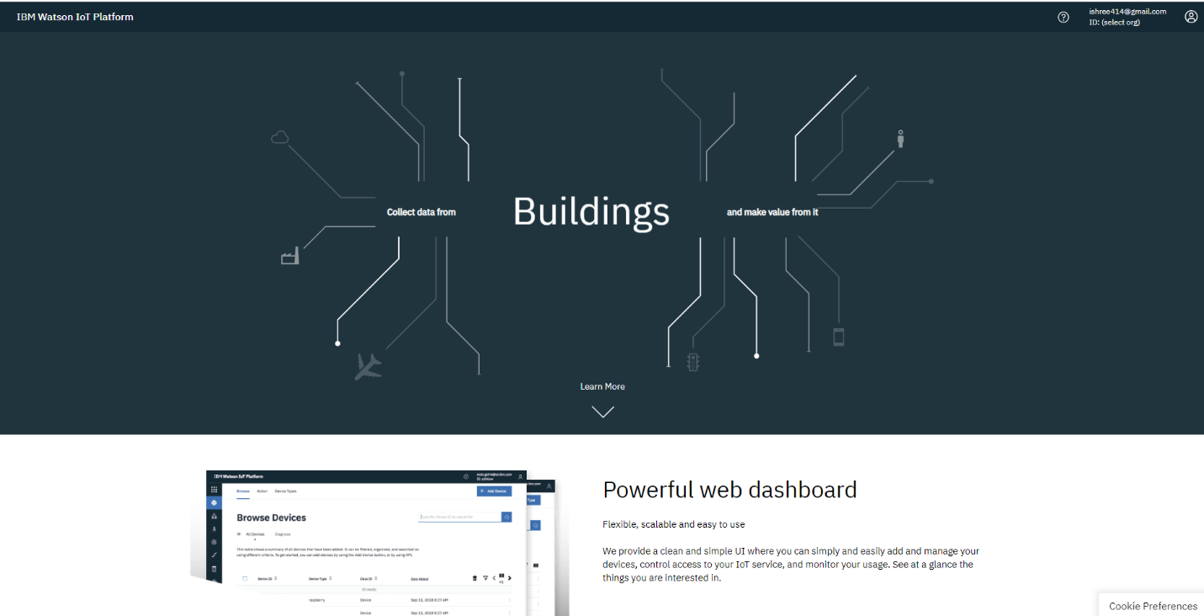

Step 8:

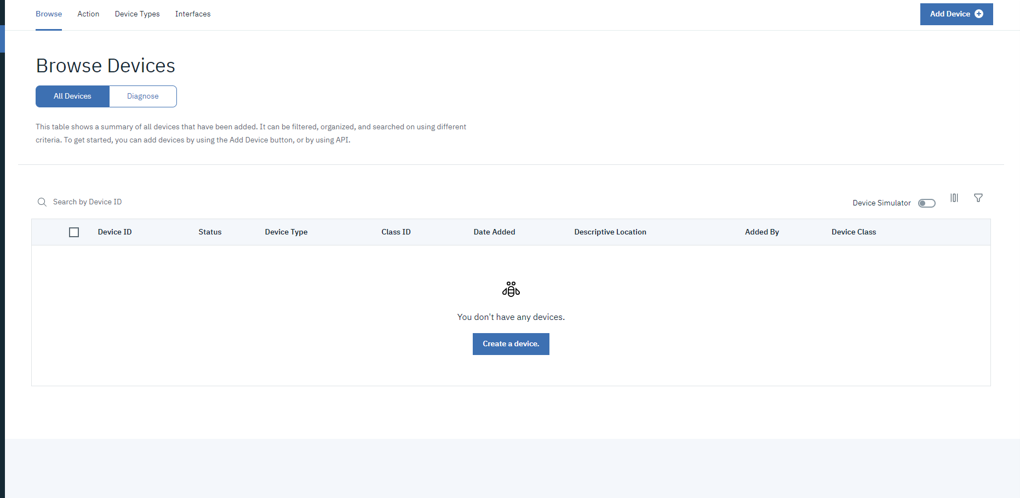

Step 9:

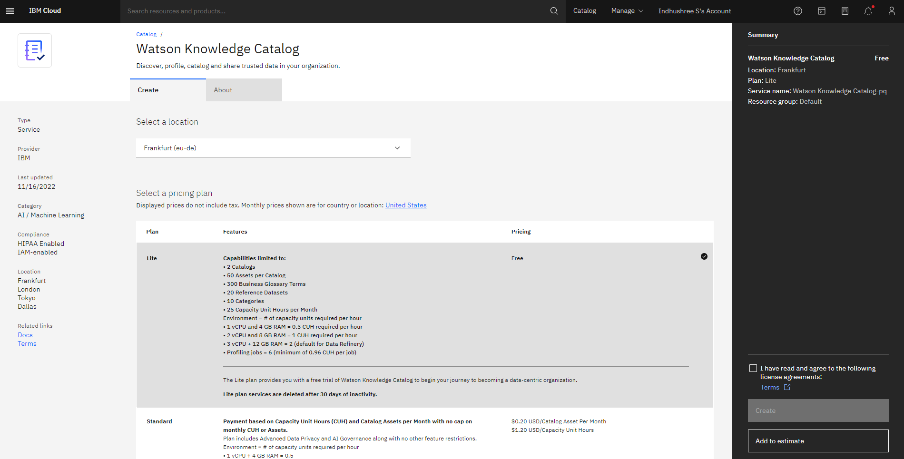

Step 10:

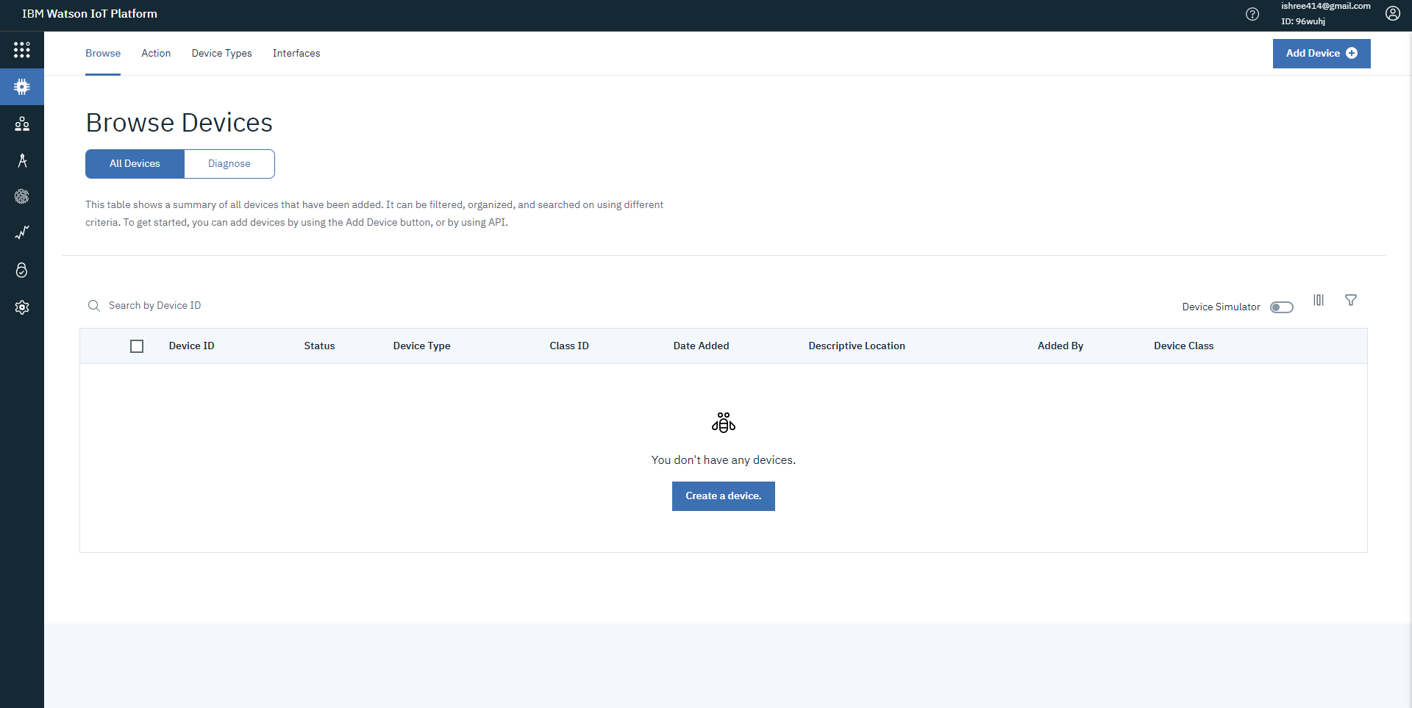

The IBM Watson IOT platform and a device was created successfully.